10. S0479 - DEFENSOR ID

1. Name & Type
Name | DEFENSOR ID
ATT&CK ID | S0479
Type | Malware — Android Banking Trojan (Ultra-Stealth / Zero-Permission-Footprint)
Also Known As | Companion app: Defensor Digital — same C2 infrastructure; developer alias: GAS Brazil
Version | Initial version — May 2020
Created | 16 November 2020 (MITRE entry)
Last Modified | 16 April 2025

2. Description
DEFENSOR ID is the most stealthy Android banking trojan in this report — analyzed by ESET researcher Lukas Stefanko in May 2020. Its defining characteristic is that it stripped away all potentially suspicious permissions except one: Android's Accessibility Service. This minimal approach allowed it to pass Google Play's security review and evade all 57 VirusTotal antivirus engines at the time of analysis. It masqueraded as a security application offering end-to-end encryption. DEFENSOR ID supports 17 remote C2 commands via Firebase Cloud Messaging (FCM) — a legitimate Google service — making network-level C2 blocking extremely difficult. An unauthenticated C2 database exposing data from approximately 60 compromised victims was found accessible during ESET's analysis.

Key Characteristics
- Zero suspicious permissions — only Accessibility Service requested — passed Google Play review
- Zero VirusTotal detections at time of analysis — all 57 AV engines failed
- Firebase Cloud Messaging (FCM) C2 — legitimate Google service — network blocking ineffective
- Supports 17 remote C2 commands including arbitrary tap/click injection
- Reads Google Authenticator 2FA codes from screen — defeats both SMS and app-based 2FA
- Unauthenticated C2 panel exposed ~60 victim records during ESET analysis

3. Threat Actor Association
Threat Actor | GAS Brazil (alias)
Also Tracked As | Developer of companion app Defensor Digital using same infrastructure
Origin | Likely Brazil-based — targeting Brazilian users
Motive | Financial — banking credential theft and account takeover
First Identified | May 2020 (ESET / Lukas Stefanko)
Google Play Status | Removed by Google following ESET disclosure

4. Supported Platforms
Platform | Notes
Android | Distributed via official Google Play Store — targets Android users

5. ATT&CK Techniques Used
Tactic | ID | Technique Name
Collection | T1417 | Input Capture — all credentials captured via Accessibility Service monitoring
Collection | T1412 | Capture SMS Messages — SMS and on-screen 2FA codes intercepted
C2 | T1437 | Application Layer Protocol — Firebase Cloud Messaging (FCM) for C2
Impact | T1516 | Input Injection — 17 C2 commands including arbitrary tap/click actions
Execution | T1407 | Download New Code at Runtime — dynamic commands received from FCM

Attack Chain Flow Diagram
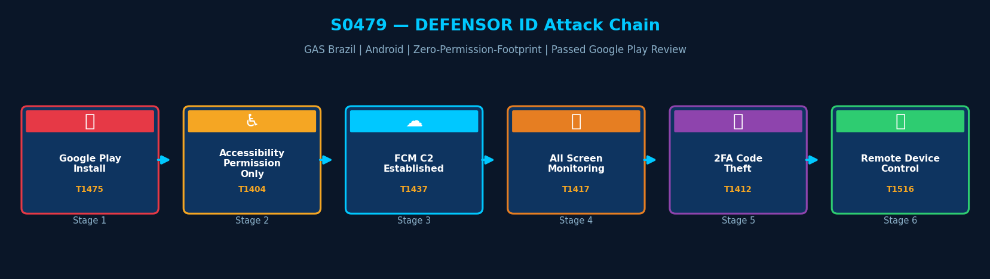
Figure: DEFENSOR ID attack chain with MITRE ATT&CK technique IDs

6. Execution Method
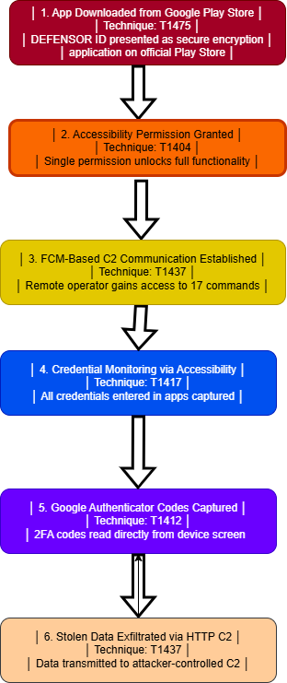
DEFENSOR ID was distributed via the official Google Play Store as a security application claiming to provide end-to-end encryption. After installation, it requests only one permission: Accessibility Service. Once enabled, all malicious functionality is unlocked. The single-permission approach defeated all Google Play security checks.

7. Persistence Techniques
DEFENSOR ID abuses already-activated Accessibility Services, which Android automatically relaunches after device restart. This provides reboot persistence without requiring an explicit boot receiver — the Android OS itself maintains the malware's persistence.

Method | Technique | Detail
Accessibility Service Auto-Relaunch | — | Android OS automatically restarts active Accessibility Services after reboot
No Explicit Boot Receiver | — | Persistence achieved via OS behavior — no RECEIVE_BOOT_COMPLETED permission needed
Implication | — | Persistence is harder to remove — disabling Accessibility is the only mitigation

8. Privilege Escalation
Detail | Explanation
Accessibility Service | Single permission grants visibility into all app interactions on device — equivalent to root-level data access
No Root Required | Operates entirely within legitimate Android permission framework
Screen Timeout Extension | Extends screen-off timeout to 10 minutes to allow remote operator operations

9. Defense Evasion
DEFENSOR ID's primary evasion technique is its minimal permission footprint — requesting only Accessibility Service with no other suspicious permissions. This defeated all Google Play security checks and all 57 VirusTotal antivirus engines. Use of Firebase Cloud Messaging as C2 makes network detection extremely difficult as blocking FCM requires blocking a core Google service.

Layer | Technique | Detail
Zero Suspicious Permissions | — | Only Accessibility Service requested — passed Google Play review entirely
All-AV Bypass | — | Zero VirusTotal detections across all 57 AV engines at time of analysis
FCM C2 | T1437 | Firebase Cloud Messaging as C2 — blocking requires blocking Google services
Legitimate App Masquerade | — | Presented as security app — users trusted it explicitly

10. Credential Access
Method | Technique | Detail
Accessibility Keylogging | T1417 | All credentials entered in any app captured via Accessibility Service events
Google Authenticator Reading | T1412 | 2FA codes read from Google Authenticator screen — full 2FA bypass
Exposed C2 Database | — | Unauthenticated C2 panel exposing ~60 victim credential sets found by ESET

11. Discovery Techniques
DEFENSOR ID monitors all launched applications via Accessibility Service, identifying which apps are in use and adapting its monitoring accordingly.

What It Discovers | Technique | Method
Active Applications | T1418 | Monitors which apps are launched — adapts credential capture per app
Screen Content | T1417 | Reads all text displayed on screen — captures 2FA codes, PINs, passwords

12. Lateral Movement
DEFENSOR ID operates solely on the compromised Android device. Stolen credentials may be used by attackers to access corporate or banking systems from separate infrastructure.

Detail | Explanation
No Lateral Movement | DEFENSOR ID has no lateral movement capability
Credential-Enabled Remote Access | Stolen credentials allow operators to access victim accounts from separate attacker infrastructure
Remote Control via FCM | 17 C2 commands enable arbitrary device control — operator actions mimic the victim

13. Command & Control (C2)
DEFENSOR ID uses Firebase Cloud Messaging (FCM) — a legitimate Google service — for all C2 communications. This makes IP/domain-based blocking ineffective without blocking FCM entirely. The malware supports 17 distinct C2 commands including app launch, app uninstall, and arbitrary input injection.

Method | Technique | Detail
Firebase Cloud Messaging (FCM) | T1437 | Legitimate Google service used for C2 — network blocking ineffective
17 C2 Commands | T1516 | Commands include: uninstall apps, launch apps, arbitrary tap/click injection
Unauthenticated Panel | — | C2 web panel found unauthenticated during ESET analysis — exposing victim data
C2 Domain | — | empresasenegocios[.]online (GoDaddy hosted)

14. Exfiltration
Method | Technique | Detail
FCM Exfiltration | T1437 | Stolen credentials and 2FA codes exfiltrated via FCM C2 channel
What is Stolen | — | All credentials from banking, crypto, email, social media apps — full 2FA codes
Scope | — | Brazilian users targeted — banking, cryptocurrency, and financial account credentials

15. Impact Analysis
DEFENSOR ID demonstrates the highest-stealth attack model in this report. Its zero-permission-footprint approach bypassed all existing security controls. Victims risk complete financial loss across banking and cryptocurrency accounts, full email and social media account takeover, and 2FA defeat. The exposed unauthenticated C2 database represents an additional privacy and data breach risk.

Impact Type | Technique | Detail
Full Account Takeover | T1417 | All banking, crypto, and financial app credentials stolen — complete account control
2FA Defeat | T1412 | Google Authenticator codes read from screen — both SMS and app 2FA bypassed
Remote Device Control | T1516 | 17 FCM commands enable full remote device operation by attacker
Google Play Trust Violation | — | Bypassed official app store security — undermines user trust in Play Store
Exposed Victim Data | — | Unauthenticated C2 database: ~60 victim credential sets publicly accessible

16. Indicators of Compromise (IOCs)

File System IOCs
IOC | Detail
App: DEFENSOR ID or Defensor Digital | Application with either name on device from Google Play or sideloaded
Accessibility Service to unknown security app | Unrecognized security application with Accessibility Service permission active

Behavioral IOCs
IOC | Detail
Screen-off timeout set to 10 minutes | Timeout extended by application to enable remote operator activity window
Accessibility monitoring all apps continuously | Unknown security app monitoring all screen content — not normal behavior

Network IOCs
IOC | Detail
FCM traffic from unrecognized app | Unusual Firebase Cloud Messaging volume from recently installed unknown app
empresasenegocios[.]online | Known DEFENSOR ID C2 domain — block at DNS and network perimeter

17. Detection & Mitigation

Detection Methods
Method | Technique | Detail
Accessibility Service Audit | T1417 | Revoke Accessibility permission from all unrecognized apps immediately
FCM Anomaly Detection | T1437 | Monitor FCM traffic volume anomalies from recently installed apps via MDM
Screen Timeout Monitor | — | Alert on screen-off timeout modifications by applications
Play Protect Enforcement | — | Ensure Google Play Protect is enabled and updated on all devices

Mitigation Methods
Method | Detail
MDM Accessibility Controls | Require IT approval before any app can use Accessibility Service
DNS Block | Block empresasenegocios[.]online at DNS level across organizational networks
Play Protect | Ensure Google Play Protect enabled and scanning all installed apps
User Education | Educate users: legitimate security apps never require Accessibility Service permissions
Regular Permission Audit | Conduct monthly Accessibility Service permission audits on all enrolled devices

Overall Defensive Posture
DEFENSOR ID represents the most sophisticated evasion approach in this report. Its single-permission model and FCM-based C2 defeat most conventional detection controls. Defensive strategy must be proactive — restricting Accessibility Service grants via MDM policy before any malicious app can abuse them. A layered defense including MDM controls, user education, and regular permission audits is essential.

18. References & Sources
# | Author / Source | Title | URL
1 | MITRE ATT&CK | S0479 — DEFENSOR ID | https://attack.mitre.org/software/S0479/
2 | ESET WeLiveSecurity | Insidious Android Malware — Lukas Stefanko (May 2020) | https://www.welivesecurity.com/
3 | ESET Ireland | New trick used by malware to slip into the Android app store (May 2020) | https://www.eset.com/
4 | Cyware | Android Accessibility Services Vulnerable to DEFENSOR ID (June 2020) | https://cyware.com/

